Practical
SUMMARY:-
The practical demonstrates the 0/1 Knapsack algorithm using Dynamic Programming, where each item is either selected or not selected, and the maximum possible value is calculated for a given capacity.
The Knapsack Problem is an optimization problem where we select items with given weights and values to maximize total value without exceeding the knapsack's capacity.
Output
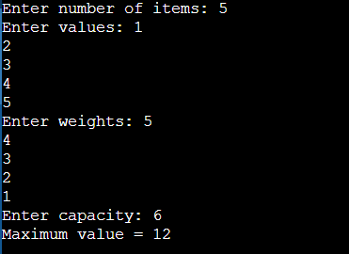
Time Complexity:
Case | Time Complexity
Best Case | O(n × W)
Average Case | O(n × W)
Worst Case | O(n × W)

Conclusion- Thus, the Knapsack Problem was successfully implemented using Dynamic Programming, efficiently finding the maximum value that can be obtained within the given weight capacity.

